**Topic: Line Graph Applications**

Time: 45 mins Marks: /45 marks

**No calculator allowed**



**Question One: [3, 2, 3: 8 marks]**



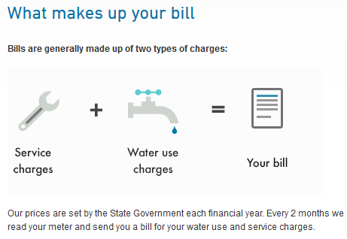

|  |  |
| --- | --- |
| **Billing Information** | |
| **Water usage in kL** | 40 |
| **Service charges** | $190 |
| **Total charges** | $240 |

To answer the following questions refer to the Water Corporation billing information on the previous page.

a) What is the price per kL charged on this bill?

b) Write an equation for total charges, **T**, based on water usage of **w** kL.

c) Graph the total charges equation on the axis below.



**Question Two: [2, 2, 2, 4, 2: 12 marks]**

****Dora is going on a treasure huntand her movements can be tracked from her starting position shown on the graph below. The scale on the graph is measured in metres.

From the start Dora moves due south 3units and the due east 5units, where she finds her first clue.

a) Mark the point on the map where Dora finds her first clue.

b) What is the exact answer for the direct distance from the first clue to the start.

The clue that she finds at this point instructs Dora to walk in a straight line for 10m, going over the bridge. Here she will find her next clue.

c) What is the point where Dora will find her next clue?

Dora is now instructed to change direction so that she is walking on a line perpendicular to the line she was just walking on. She is told to walk downhill along this line and she will find the treasure!

d) What is the equation of the final line she walks on?

e) Upon finding the treasure, Dora excitedly writes down the coordinates of the point where the treasure is. She writes (9, 4). Is this where she found the treasure? Justify your answer mathematically.

**Question Three: [3, 2, 2, 2: 9 marks]**

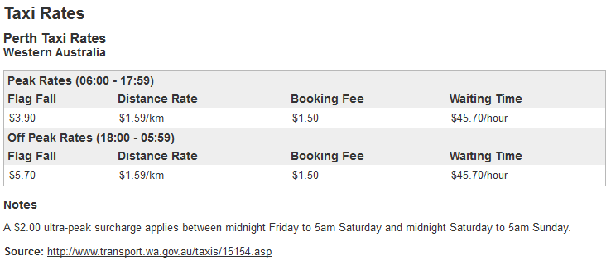Consider the following taxi rates.

a) Assuming no waiting time is charged, calculate the off-peak rate cost for a taxi which was booked and traveled a distance of 100km.

b) After how many km will the cost be the same regardless of whether it was peak or off-peak. Justify your answer mathematically.

The linear equation below models the cost of a taxi booked during peak times, assuming no waiting time is charged.

c) Explain how the line above was derived from the table on the previous page.

d) Graph the line for the total cost of a taxi booked during off-peak time, assuming no waiting time is charged.

**Question Four: [3, 2, 1, 2: 8 marks]**

Green-thumbs gardening service charge customers based on an hourly rate and a standard disposal fee for removing all of the garden waste.

Green-thumbs worked on Mr Jones’s garden for 5 hours. His gardening bill is $175 including the disposal fee.

Green-thumbs worked on Mr White’s garden for 3 hours and he was charged $125.

a) What is the equation for the total cost of gardening, **G**, based on the number of hours worked, **h**.

b) Graph the equation on the axes below.

The costs associated with rubbish disposal have begun increasing and as a result Green-thumbs need to increase their disposal fee by $10.

b) Describe the impact of this on the line.

With the increasing cost of living, Green-thumbs have decided to now increase their hourly rate as well by $25 an hour.

c) Describe the impact of this on the line, and graph the new line on the same axes.

**Question Five: [6, 2: 8 marks]**

The cost of an airplane ticket is modeled on a linear equation with a flat rate being charged for entertainment and inflight service and the rest of the cost of the ticket is based on the number of km travelled. All airlines charge their tickets using this model but have different prices associated with them.

* Andy purchases a ticket with Jumbo Jets for an 800km journey and it costs him $100.
* Dwight buys a ticket with Air Antics for a 1200km journey and it costs him $195

Based on their pricing equations, both companies would charge $30 for a 100km journey.

What would each company charge for a 1000km journey?

A third company charges $50 for the entertainment and inflight service and the same rate of cost per km as Air Antics.

b) Describe what this line would look like if it was graphed on the same axis as the Air Antics’ line.

**Topic: Line Graph Applications SOLUTIONS**

Time: 45 mins Marks: /45 marks

**No calculator allowed**



**Question One: [3, 2, 3: 8 marks]**





|  |  |
| --- | --- |
| **Billing Information** | |
| **Water usage in kL** | 40 |
| **Service charges** | $190 |
| **Total charges** | $240 |

To answer the following questions refer to the Water Corporation billing information on the previous page.

a) What is the price per kL charged on this bill?



b) Write an equation for total charges, **T**, based on water usage of **w** kL.



c) Graph the total charges equation on the axis below.









**Question Two: [2, 2, 2, 4, 2: 12 marks]**

****Dora is going on a treasure huntand her movements can be tracked from her starting position shown on the graph below. The scale on the graph is measured in metres.

From the start Dora moves due south 3units and the due east 5units, where she finds her first clue.

a) Mark the point on the map where Dora finds her first clue.

b) What is the exact answer for the direct distance from the first clue to the start.



The clue that she finds at this point instructs Dora to walk in a straight line for 10m, going over the bridge. Here she will find her next clue.

c) What is the point where Dora will find her next clue?







Dora is now instructed to change direction so that she is walking on a line perpendicular to the line she was just walking on. She is told to walk downhill along this line and she will find the treasure!

d) What is the equation of the final line she walks on?



e) Upon finding the treasure, Dora excitedly writes down the coordinates of the point where the treasure is. She writes (9, 4). Is this where she found the treasure? Justify your answer mathematically.



.

**Question Three: [3, 2, 2, 2: 9 marks]**

Consider the following taxi rates.

a) Assuming no waiting time is charged, calculate the off-peak rate cost for a taxi which was booked and traveled a distance of 100 km.

b) After how many km will the cost be the same regardless of whether it was peak or off-peak. Justify your answer mathematically.



The linear equation below models the cost of a taxi booked during peak times, assuming no waiting time is charged.

c) Explain how the line above was derived from the table on the previous page.



$y-intercept=fixed cost=1.50+3.90=5.40$

$$gradient=distance rate=1.59$$

d) Graph the line for the total cost of a taxi booked during off-peak time, assuming no waiting time is charged.

y-intercept

 parallel

**Question Four: [3, 2, 1, 2: 8 marks]**

Green-thumbs gardening service charge customers based on an hourly rate and a standard disposal fee for removing all of the garden waste.

Green-thumbs worked on Mr Jones’s garden for 5 hours. His gardening bill is $175 including the disposal fee.

Green-thumbs worked on Mr White’s garden for 3 hours and he was charged $125.

a) What is the equation for the total cost of gardening, **G**, based on the number of hours worked, **h**.

|  |  |
| --- | --- |
|  |  |

b) Graph the equation on the axes below.



The costs associated with rubbish disposal have begun increasing and as a result Green-thumbs need to increase their disposal fee by $10.

b) Describe the impact of this on the line.



Shift the graph up 10 units.

With the increasing cost of living, Green-thumbs have decided to now increase their hourly rate as well by $25 an hour.

c) Describe the impact of this on the line, and graph the new line on the same axes.

 Graph is steeper.

**Question Five: [6, 2: 8 marks]**

The cost of an airplane ticket is modeled on a linear equation with a flat rate being charged for entertainment and inflight service and the rest of the cost of the ticket is based on the number of km travelled. All airlines charge their tickets using this model but have different prices associated with them.

* Andy purchases a ticket with Jumbo Jets for a 800 km journey and it costs him $100.
* Dwight buys a ticket with Air Antics for a 1100 km journey and it costs him $195

Based on their pricing equations, both companies would charge $30 for a 100 km journey.

What would each company charge for a 1000 km journey?

|  |  |
| --- | --- |
|  |  |

A third company charges $50 for the entertainment and inflight service and the same rate of cost per km as Air Antics.

b) Describe what this line would look like if it was graphed on the same axis as the Air Antics’ line.

$$50-13.50 = 46.50$$

Parallel and shifted up 46.50 units